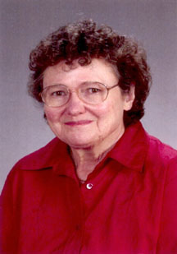

Aug. 18, 1937-May 9, 2005
Veterinary Scholarship Fund
Barbara Deeb, DVM, MS
For the love of Rabbits Rodents & Ferrets
HOME
This scholarship fund is established in memory of Dr. Barbara Deeb. She was a compassionate veterinarian to her patients and clients alike. In addition to making a living, she also donated much of her time to help rescued animals. We hope that recipients of this scholarship will follow in her footsteps, keeping her memory & compassion alive.

Dr.Barbara Deeb enjoyed & excelled at so many different aspects of life:
She was a compassionate veterinarian to animals and to their caretakers.
She stayed in touch with friends she met over the years all the way back to High School friends.
She belonged to the Audobon Society and enjoyed birding.
She walked through many parks enjoying the flowers, trees & nature.
She loved playing tennis.
She loved to travel.
She supported with many volunteer hours, the House Rabbit Society & Best Little Rabbit, Rodent & Ferret House in Seattle, WA.
She loved continuing to learn & documented her findings so others could learn.
She loved teaching.
She was a painter. Many of her paintings portrayed Lebonan, where she and her family spent 14 years.
She was a wonderful wife, mother and grandmoter.
She loved all animals. In addition to Sparkles & Rudy her clinic rabbits, she also had ferrets, birds, cats and dogs.
HOME
SCHOLARSHIP INFO
PUBLICATIONS
PHILOSOPHY
ABOUT US
FUNDING
FAMILY
FUNDING/DONATE
ABOUT US
LEBANON

EDUCATION

